**Project Design Phase – II**

**Data Flow Diagram & User stories**

|  |  |
| --- | --- |
| **Date** | 29 October 2023 |
| **Team ID** | Team-592681 |
| **Project Name** | Early Diagnosis Of Diseases Using Image processing Of Human Nails |
| **Maximum Marks** | 4 Marks |

**Data Flow Diagrams**:

A Data Flow Diagram (DFD) is a traditional visual representation of the information flows within a system. A neat and clear DFD can depict the right amount of the system requirement graphically. It shows how data enters and leaves the system, what changes the information, and where data is stored.

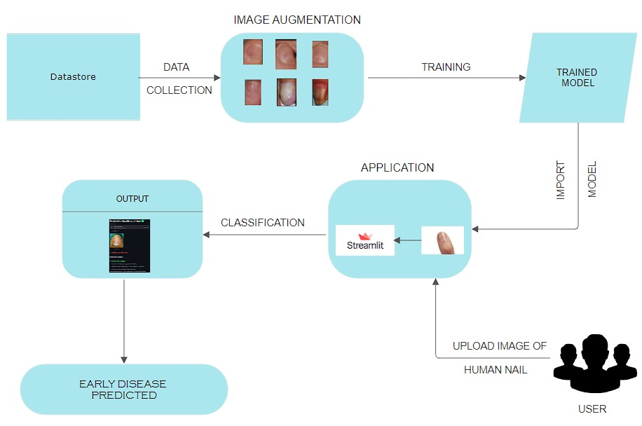

**USER STORIES** –

|  |  |  |  |  |  |  |
| --- | --- | --- | --- | --- | --- | --- |
| **USER TYPE** | **Functional**  **Requirement** | **User Story No.** | **User Story / Task** | **Acceptance Criteria** | **Priority** | **Release** |
| Health Care Professionals | Data Collection and Diagnosis | USH-1 | Upload Patient Nail Images | Healthcare professionals can upload nail images of patients, attaching relevant medical history and patient information. | High | Sprint 1 |
|  |  | USH-2 | View Patient Diagnosis Results | Healthcare professionals can access diagnosis results for their patients, including disease classifications and recommended actions. | High | Sprint 1 |
|  |  | USH-3 | Schedule Teleconsultations | Healthcare professionals can schedule teleconsultations with patients for further guidance based on diagnosis results. | Medium | Sprint 1 |
| End Users (Patients) | User-Friendly Interface | USE-1 | Upload Nail Images for Analysis | Users can easily upload nail images for analysis through a user-friendly web interface. | High | Sprint 2 |
|  |  | USE-2 | Receive Personalized Recommendations | Users can receive personalized recommendations based on diagnosis results to manage their health effectively. | High | Sprint 2 |
|  |  | USE-3 | View Diagnostic History | Users can view their diagnostic history and track changes over time to monitor health progress. | Medium | Sprint 2 |
| Administrators | System Monitoring | USA-1 | Monitor System Performance | Administrators can monitor system performance, user activity, and ensure smooth and secure system operations. | Medium | Sprint 2 |